This is lesson 4 of our canvas pro course. In this lesson we are going to be learning how to interact with the canvas So we know how to resize and we also know how to draw elements on it , we know how to animate those elements but we don’t know how to add interactivity with our canvas so that when we hover over it or click on it or when we put our finger on our phone or so forth we don’t know how actually get these elements ( maybe that are drawn in the canvas )to interact with the events that are occurring on the screen

0:23

So this is the end goal we want to be able to produce something cool like as shown below



Where we have animation our ball bouncing edge off the screen but at the same time circles are growing as they come in contact with our mouse so this is going to be the end goal and this is what we are going to produce by the end of the lesson so where we left off where we had large bunch of large black circles bouncing off the edges of the screen in slow motion as shown below



So we have a little bit to go We have to change the size of these circles randomly we need to change their colors randomly and we also have to add interactivity teacher was talking about

So lets go ahead and add interactivity. To add interactivity in your canvas piece you are going to know one important concept and that concept is event listeners So if you have not heard of an event listener, basically it’s a function that’s going to be fired over and over again as long as an event is occurring on the screen SO lets say my event is mouse movement If we are moving our mouse we are basically going to be calling a function within our javascript and that function is going to be called as long as the event is occurring. So only we move our mouse. And there are multitude of different events we can call. We can call things such as mouse down , click event we can call a mouse up event we can also call touch events for mobile devices So to create an event listener we are going to go in our code and call our window object and add an event listener by addEventListener method it takes three argument but we only need to focus on the first two. We first need to declare what type of event we want to monitor in the first argument we want to monitor our mouse position whenever we move it across our screen. So in order to monitor our mouse movement we are going to put it mousemove as the event we want to monitor so now that we know which event we want to monitor, we now need a function to call whenever this event occurs so we put the function name that we want to call so we can insert a function name such as animate function in here . But that would not really make sense so its much easier to ad an anonymous function so we are going to do that instead now our code is going to look like below

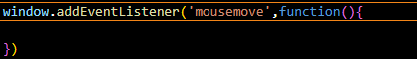

So now whenever we move our mouse across the canvas this event, this function is going to be called and we can test this out by inserting a console.log there and put some dummy text there

2:32

Say “Hello” Now save the file and then you will see whenever you move your mouse then console.log will be shown below



Now you will see our console will be printer whenever we move our mouse If we stop then it will stop incrementing (console call) But when we move our mouse. If we stop, it’s not going to be incrementing when we move our mouse is going to call the function again and again.

So basically in order to get these circles to interact with our mouse whenever we are moving it we need to take into consideration some geometry we need to get the distance between the mouse position and distance between each of these circles and the distance between mouse position and each of these individual circles and if the distance between the mouse position and each of these individual circles is say less than 50 then we want to make sure these circles are growing and if it is greater than 50, we want to make sure that circle shrinks down back to its original So if we want to get the distance between our mouse position and one of these circles then we need to get our mouse position and we can do that through our event listener over here. This anonymous always have what’s known as an even parameter so we are going to add an event parameter and now if we console.log() it then our event listener code will be like below

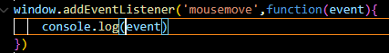

Now in output as you move mouse you will see something like below

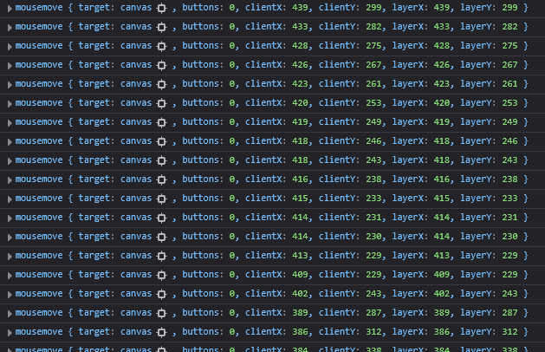

You will see that we actually have an object being returned to us and these object represents the data that are associated with our event as its happening o the screen when we move out mouse

So you will see by expanding one object in the console that as shown below

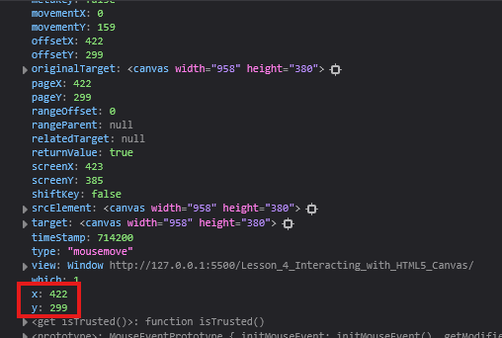

Now you see that when this event occurs our mouse was at an x position at 422pixels and y position of 299pixels. Now when you move our object then this objects are again created So by this event parameter we can go ahead and grab the x and y values of the event that is occurring

4:15

And we are going to use this x and y values to compare them to the position of the circles on the screen and once we compare them to the positions of the screen that’s when we can calculate the distance between our mouse position and the actual x and y value of the circles So since we first want to get the x and y value of our mouse. So we are going to create a global variable mouse and inside it we store an object having parameter x and its initial value is undefined and y value is also undefined. Now it will look like below in our code

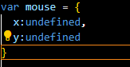

We don’t want the parameters to set just yet we are going to set these within our mousemove event listener. So we initialize them by assigning mouse x to the event.x and same for y Now our mousemove event listener will look like below

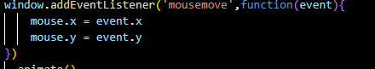

We check this out by console logging our mouse .Now we when a mouse is moved then you will see we have an object with just an x and y coordinate. And we are going to use this as Teacher said to compare it to the actual position of each individual and if the distance is less than 50 then the circle is going to grow. SO now we need to compare to each individual circles coordinates

So now first we need to is we need to get the distance between out mouse positioning and the actual circles position So for that all we need to do is select our mouse and from our mouse x property we are going to subtract each individual circle’s x coordinate and if this is less than 50 we want to call a function

So first we need to create a conditional So now our if condition in update method will look like below

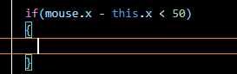

So if the distance between the circle and the mouse position is less than 50 then we increment our radius as shown below

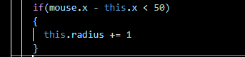

Now our output will be like below

6:32



You will see everything to the right starts growing sporadically (without any control) and also left side circles also increase but some remains as it is. Why so

We only want to track what is within 50 pixels within our mouse positioning. So this is not good enough. This is not going to cover all of those use cases(situations) of all the condition we want to track in order to ensure it happens So right now all the circles to the right of the mouse are growing

Because lets say take an example in which one circle x is 200 and mouse position is 100 well if that’s case we are going to get a value of negative 100 and obviously that’s going to be less than 50. So that means all the circle to the right of the our mouse are going to grow by one. We need to take that into account that we don’t want that to happen So a result, we are going to and operator in our conditional much take that the distance between the mouse and the circle is larger than -50

So our conditional code in update will look like below

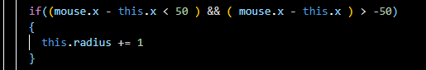

Output will be like below



Now you will see when my mouse is in left side of the window screen then right circle does not increase it size but when I move then the circle below the mouse expand in size

It will work in whatever is within 50 pixel of our mouse from the left and right But the issue is that you will see is everything to the top and bottom of the mouse is still growing So we need to take into account as well the circles above and below our mouse should only be within the distance of the mouse So right now we are only tracking our x values. We need to take into account our y values as well so similar to we did with x we make sure the y value should be less than 50 but greater than 50

SO our conditional will be like below



The output is shown below



Now you can see that the circles within 50 pixels distance of our actual mouse are going to grow But it still leaves us with a bit of an issue. These circles keep growing and the ones that are not 50 pixel within the distance of the mouse they don’t actually shrink as they should be as shown in the demo by the Teacher earlier in the starting of the lesson

8:55

So that’s something we will take into account is what happens when this conditional is not true and we can check it by checking if it is not true by adding an else statement at the end of if SO if this is not going to true then we are going to decrease it the radius of each individual circle by one

SO now our code will look like below

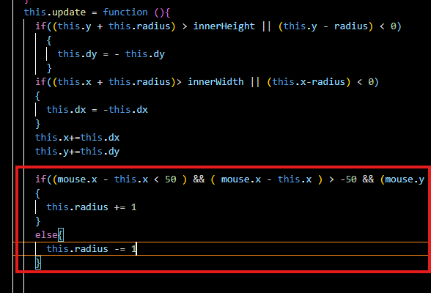

Now our image will look like below



So basically al the circles are shrinking to the point where they are not even visible and we even got a error within the console as shoen below

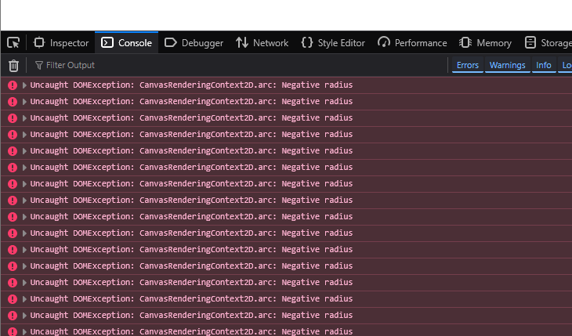

. This is happening because our mouse is 50 pixel away from all and the radius get shrinked to negative radius. So we need that make sure that these circles do not decrease past a certain point SO instead of just doing else we will do else if and in tis else if code we add the code of reducing the radius and in its condition such that circle radius should be greater than 2 only then shrinking will happen by one.

Now our code will look like below

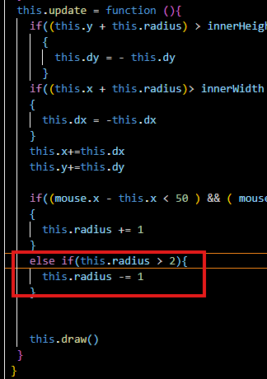

So by this way the radius of the circle they won’t actually go into nothing. They will be at least two pixels wide in radius. Once they go outside the distance of our mouse. Now our output will be like below



So we can see when we hovering over these, the circles don’t go back to their original They go down to a smaller size as specified. Bit at the same time they are still kind of achieving that we wanted in the first place. We are hovering over the circles then they grow but if we hover out of them then they are going back down to a certain point

10:15

So to achieve the same effect that teacher showed in the starting we need to ensure that these circles don’t expand past a specified list as they grow. So this is going to go in this conditional.

Right now the conditional is managing when the circle should grow when the mouse is within 50 pixels of each individual circle So to ensure this we are going to not add to the current conditional as it will become lengthy we are going to add a new conditional within this current conditional we are going to say that increase the radius if it is less than 40

Now our conditional in update will look like below

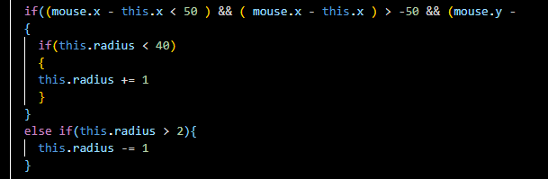

Now our output will look like below



Now our circles have a maximum limit in which they can grow to. They can’t grow past this limit because we added this new conditional

And now for good coding purposes we store the 40 into maxRadius global variable

SO now our code will look like below

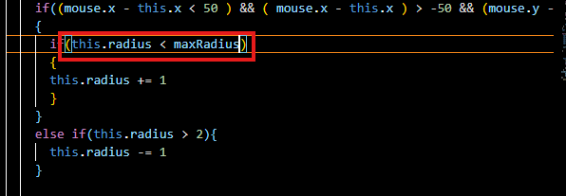

So now we are following some better coding convention because we are storing number in a variable instead of hardcoding it. and we can do the same thing for our minimum radius we declare minRadius So now our code will look like below

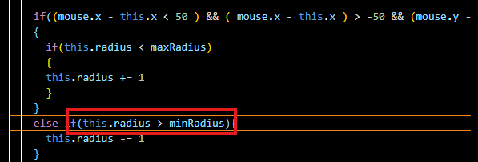

So we have mor readable code now but there are still things we need to do here in order ot get the nice aesthetic that Teacher showed us in the example ion the beginning of the lesson So some of the thing that we need to change up the color of these circles. And change up the color we need to do a little bit of math here SO it’s a little interesting topic. We need to create what is known as color array

It is an array the contains all the color we like our circles to be. If we want our circles to be randomized between five different colors. Our circle array would contain five different objects and within these we specify hexadecimal values that will represent individual colors so lets just go ahead and put some random colors in here for now. And then when we actually want to make things start looking good that’s when we will go ahead on over to a website called cooler which will go ahead and give us Color pallete and we can use hexadecimal values from there too and there it give us a nice look instead of just randomized colors as we are doing right now.

Now we declare the colorArray and store random color hexadecimal values in it as shown below

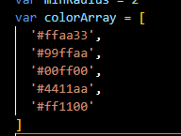

13:15

So now we have an array of colors, but now we need to actually inset these color within each individual circles fill property

We are drawing our circle in draw method of circle object we see that it has fill style and strokestyle we remove the strokeStyle Now aft er draw method will look like below

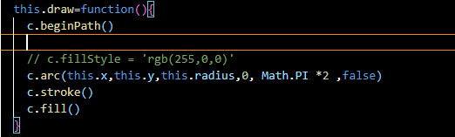

We have just black circles for now instead of blue boundary now I will not show it since it is very obvious

Now we need ot change our fillStyle for each individual circle and each circle is going to be equal to one of the element in the color array So we randomly select a color code from colorArray

So we add a code colorArray[Math.random() * colorArray.length]

ColorArray.length handles the length of the array as it can be dynamically changed by you when you multiply Math.random to the colorArray.length then you get a number between 0 and the length of the array but it still will not work because we are getting a decimal number and array does not take a decimal number as an index number in array so we will convert decimal to int. we can do so by the Math.floor function which round down a decimal number.

For example if you have a number 4.7 then by Math.floor we get a 4

So now our code will look like below

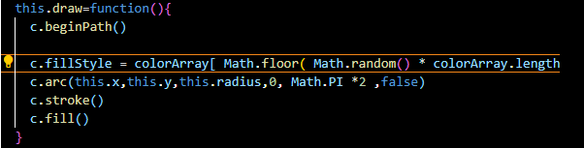

Now our output will look like below



And now you will see that we actually have a pretty wild effect going on here. This Is happening because we are calling our draw function every single time within our update function. And since we are calling random color from an array over and over again well the color are dynamically over and over again as well. So we want to make sure that the colors of our circle are only set once rather than set over and over again within this draw function and to do that we add a new property to our circle class that is equal to random color from colorArray as marked below

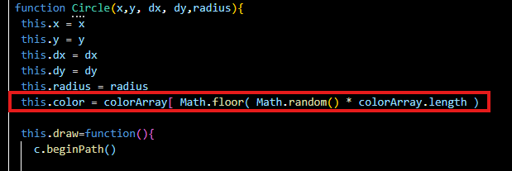

So our fill style will be equal to this.color as marked below

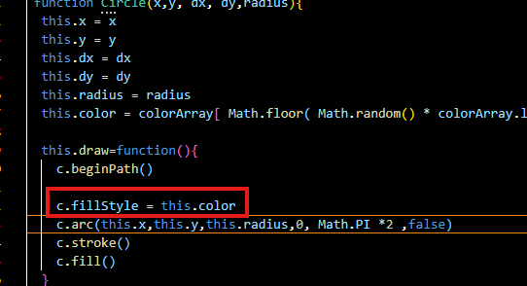

Now our output will look like below



This solve the issue of our blinking circle and now so we have nice looking colors here. Some randomized colors An we are going to change these up to a nicer color as soon as we finish everything else

17:17

But go ahead and play around with this. Change up the color a bit Go ahead and change up the randomization stuff. See what you can do to create cool type of stuff

Its really fun becasue its really fun and its going to help you learn the most on the long run Now we need to randomize actual size of the circles So as you saw in the output that they are all very small(like jugnu)an they are all very uniform. We want to make sure that the circles that ar bouncing around are random sizes to give it a little more variety a little more of a randomized feel to our actual canvas piece. So to actually randomize actual minimum size of the circle we are going to be giving our circles a random variables. So all our circles radii, they are being declared within the for loop snippets as shown below

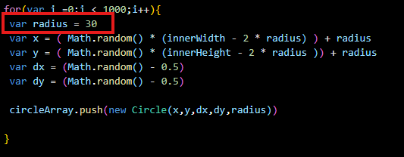

And we can see that we have just hardcoded in a value of 30 for our radius as marked above. So instead of a value of 30, let’s go ahead and do a math.random here we want to get a random value from 1 to 4 now instead of 0 through 4 so we add 1 after Math.random so that if 0 occurs then 1 will be added so that circle has at least have radius as marked below

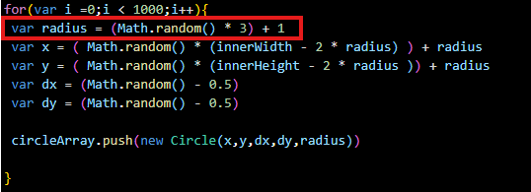

SO minimum radius we get is 1 and maximum radius is 4

SO we want to make sure our circles have a minimum radius of at least 1. So we should make things look a little different over there

Now you will see some circles are smaller than others and some are larger are there as shown below And it’s kind of giving it a nice variety compared to what we had before



If we hover over then eventually circles will become uniform

19:22

And that is because we have set minimum radius a hardcoded minimum radius in our code as shown below

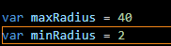

That is global in nature which says that after a circle grows and shrink back down that is going to be two. So it’s not actually shrinking back down to its respective original size but to a global minimum radius

**Note:-**

I have observed that the circle which is less than the minimum radius by only almost 1 in decimal point they go back to their original shape as it is almost close to minimum radius but the size is changed of those circles who are very low as compared to global minimum radius then after growing and then shrinking the circles will be equal to the minimum radius.

So we want to make sure our circle shrink down to their original radius rather than the global minimum radius. So to do this we are going to be creating another property. This is going to be creating another property. This is going to be called this.minRadius . So each individual circle is going to have its own individual minimum radius because one circle minimum radius could be 1, while the other could be three, the other could be 2.5. We want to make sure that each circle has its own minimum radius so it shrinks down to what it original was so instead of setting minRadius we are going to set it to circle’s original radius. As shown below in our class

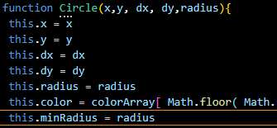

So this radius right there

So as we know our circle will be altered by the conditionals as shown below

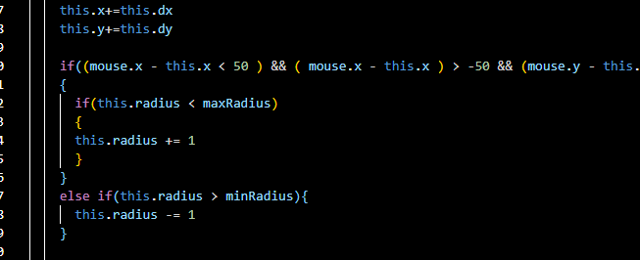

The radius of circles going to be increasing or deceasing depending on the mouse positioning but this .minRadius is not going to be altered at all. We are going to say keep decreasing the size of our circles as long as the circle is greater than each individual circles minimum radius and with that in place you will see that circle actually shrink down to their original size and not one uniform size

So what we did is replace the minRadius with this.minRadius as marked below

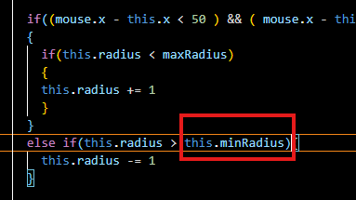

So we are adding some nice variety here, some clean code and some stuff that’s ensuring that our circles are going back down to their original size. So this is good but not great at the moment Ther still a lot of white space when the circles expand as marked below(who knows)

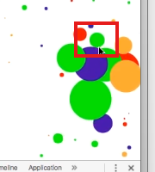

And its not appealing to the Teacher eyes So we go ahead and add more circles to our circle array by increasing the range of our loop.

Now we increase the range now it will look like below

’

Go ahead and mess around with these. See How many circles you can have without crashing your program

21:11

Lets go ahead and refresh and load the page then it works but if we make the window full screen Then it will work on that part of the window in equal to the previous less dimension of the window as shown below

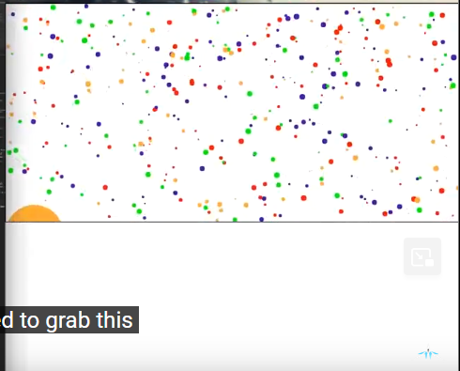

The issue we are seeing here is that why the canvas is not being responsive to the width and height of our browser. Well that is because we need to add another event listener specifically file resizing our browser window. So right now we have an event listener of mouse move lets go ahead and add an event listener of resize in our code This is going to be called whenever the browser is resized So we need to pass a function to the resize event listener Now we need things to ensure that our canvas is the full width and height of our browser each time we resize it To ensure that all we need to do is grab the code as marked below

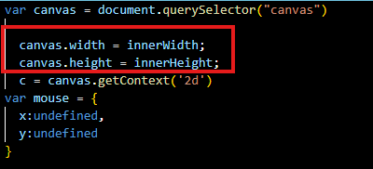

By marked above we resized our canvas to the browser window based on its first refresh And we want to make sure that we are calling this canvas resize code every time the browser is resized

So now our resize even handler will contain this code as shown below

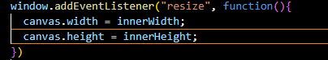

Now if we expand our window then Now this will not happen and now you can see the all the circle moving towards the new space made by the expanding window as shown below



So out canvas is going to be the full width of the full actual browser

Now you can see above when we do dragging above then you can see that canvas is actually extending but our circles they are starting to move into the other side of the canvas but they are not bring generated dynamically when we resize our browser (who knows) SO to insure circles are being generated dynamically each time the browser is resized we need to add few initialization techniques to our event listener So what’s going to happen is that we are going to call a function called init each time we resize our canvas but now we need to create another function called init So right above our animate function and now withing this init function we are going to basically be resetting our circles array

So we are going to call all this code as shown below to in our resize event listener

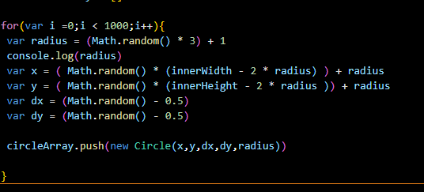

So this code will be called again and again each time we resize our browser So we are just basically just replacing all the circles generating them in new position so that hey are always going to be filling up the entire screen

So our init function code look like below

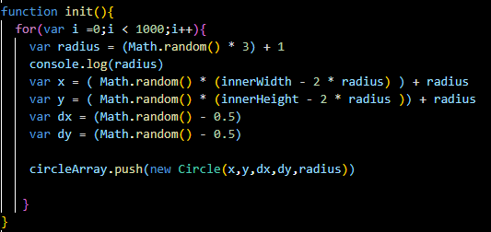

Now we need to make sure that we are actually calling it so it can be generated first time so we call it before calling of animate function as shown below

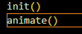

And we also call it inside resize event handler as marked below

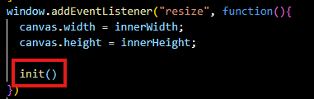

Now when we resize our window then you can see like below



Now you can see above that we are generating multiple circles over and over again and it start to get pretty laggy as our browser is handling multiple circle at once .Lets refresh and go ahead and find out what’s happening

23:53

So each time we are calling init each time we resize our browser and since we are calling inti over and over again. It suppose to generate 800 circles and it is also pushing 800 circles into our circle array. We are not actually resetting our circle array back to zero. We are just adding circles on and on to the end of the array. So to ensure that we are resetting it to clean state we are going to say circleArray = [] right before we call all the circle generation So our event handler will look like below

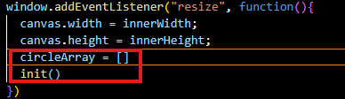

Now our output will look like below



Now that fixes our issue and circles are being generated dynamically as we go about resizing our browser which is exactly what we want. So to finish this lesson lets go ahead and choose better color pallete. So we go get something that’s more interesting a little more eye pleasing than what we have right here Now Teacher choses the website **Kuler** for his color Pallete. I think now Kuler is overtaken by Adobe

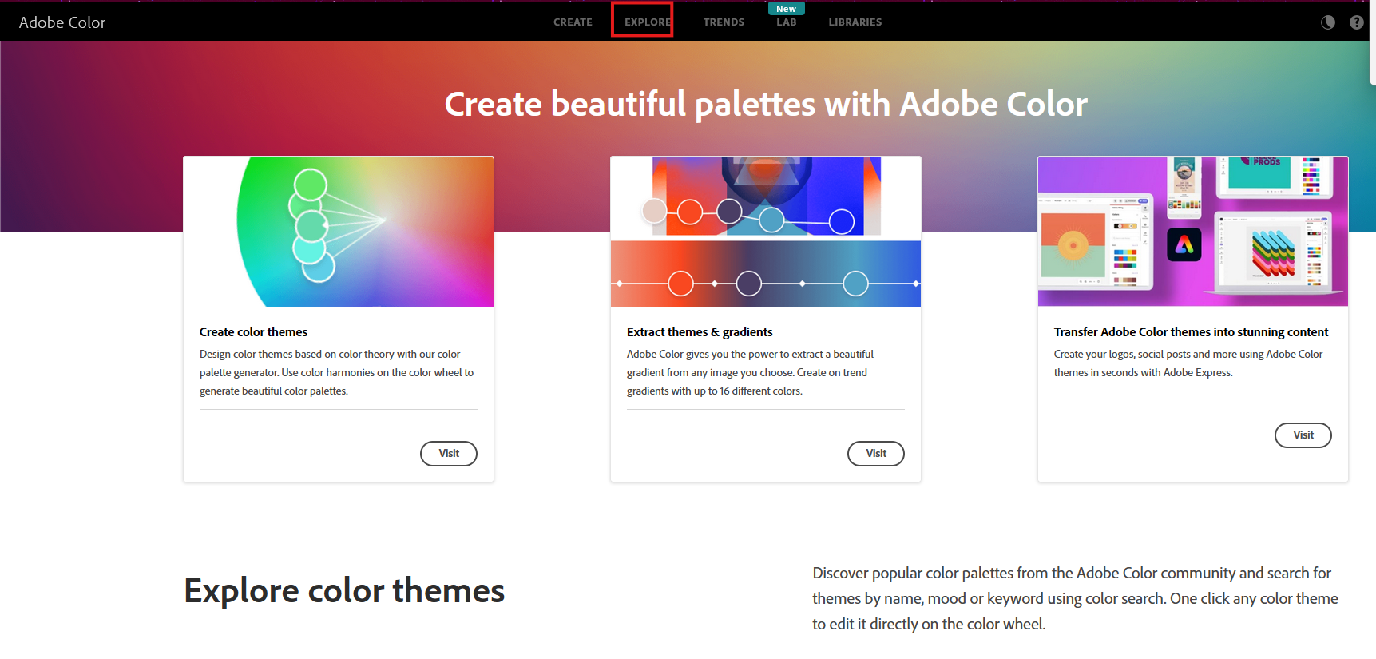

Now click on explore as marked above to explore different color palletes that people have created

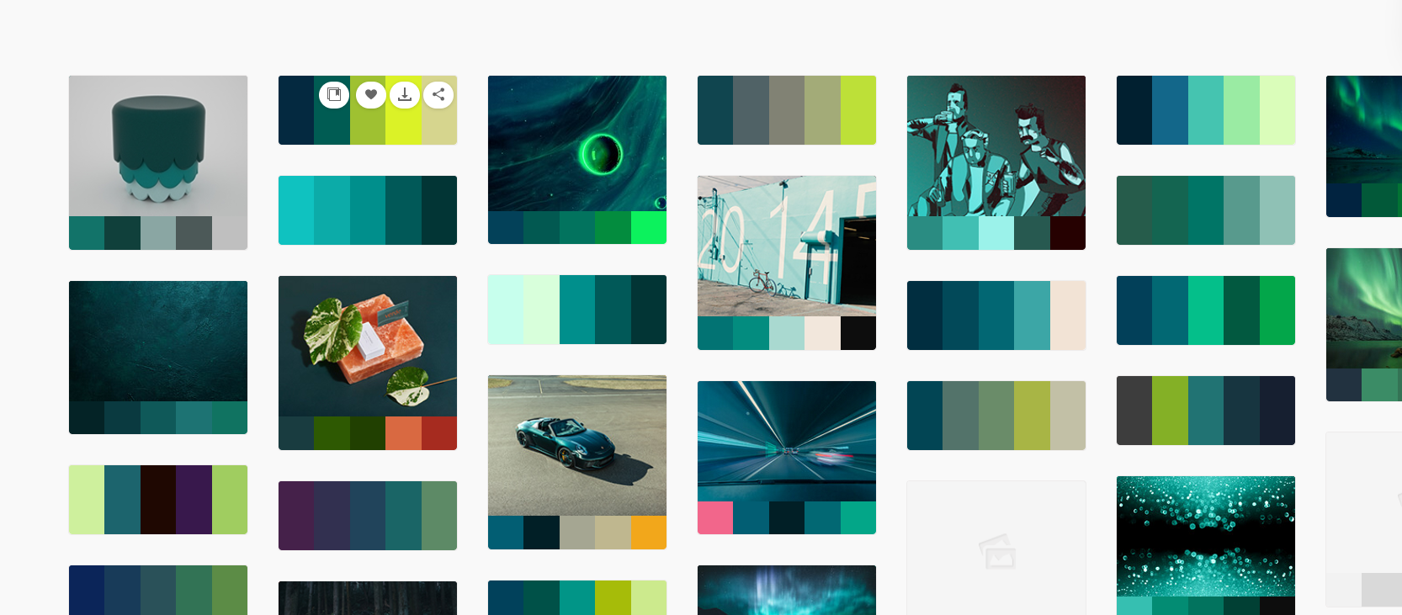

Now you can see different color pallete created by many peoples Just go through them these are well picked out color themes for the most part. Pick something that’s going to be eye appealing to you. Personally Teacher like A palette named Flat UI. I could not find it so o search it here and I find it as marked below

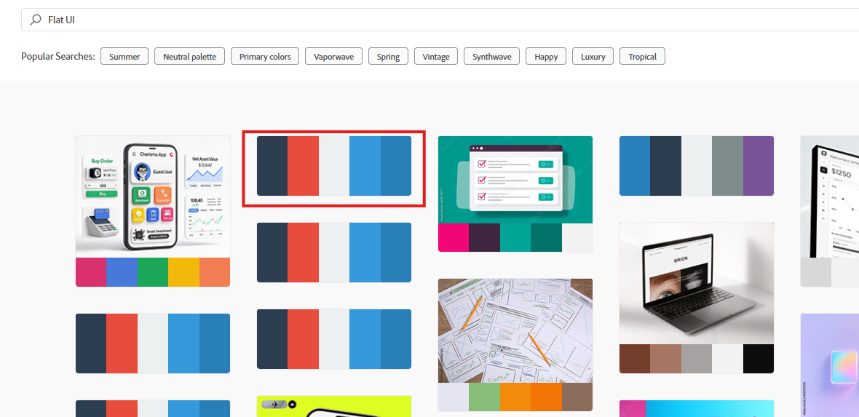

The flat UI Teacher think is personally closer to what was in demo. Click on it and then in new window the color pallet color hexadecimal values as shown below

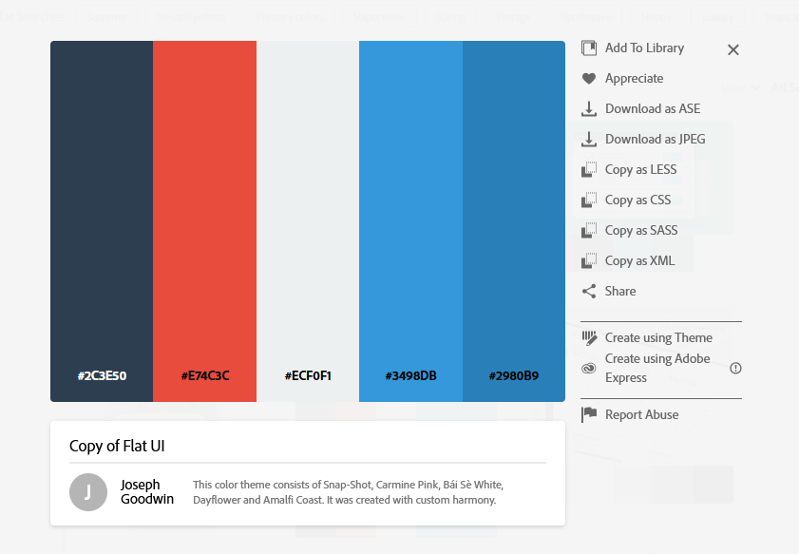

So if we want our circles color from this pallet so we copy and paste the hexadecimal values of these colors to the circleArray.

Now after copying and pasting our color array look like below

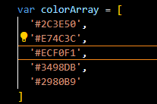

Now we have what should be better color pallete



Now in our output as shown above you can see it is lot better looking that it was. This is a better looking as the colors were handpicked to blend and give off a more professional vibe. So now we have full-fledged canvas piece that takes animation, interaction and browser resizing into consideration. We also know that four basic skills required to become a canvas prop and should now we have a solid foundation that you can use when developing any interactive canvas piece. In oiur next step try replacing the art drawing with point, lines , rectangle and even images(who knows). Try different randomization techniques See what other coinditional you can add to make other objects react with their environment. There is a lot you can do here. A lot to experiment with. Just take it into your own arms what really you can do to produce some badass canvas pieces. In upcoming lesson we could learn how to cover specific one-off canvas animation such as how to make a bunch of particles on screen attract to a certain point (who knows) and How to create HTML 5 canvas games

See you in next lesson.